TITLE: COURSEWORK

NAME: JOSHUA ADDAI-MARNU

STUDENT NUMBER: 19548571

COURSE: DATA SYSTEM CONCEPTS AND FUNDAMENTALS

DATE: 10/O1/2023

**PART B**

**MAIN ENTITIES AND RELATIONSHIPS BETWEEN ENTITIES OF EXCEL UNIVERSITY DATABASE**

* **Staff mentors Staff**

Staff(Mentor) mentors Staff(Mentee).

1. This is a recursive relationship(non-identifying relationship) between two entities, that is Mentor(Staff) and a Mentee(Staff).
2. Role names “Mentor(Staff) and Mentee(Staff)” were assigned to migrating foreign keys making the relationship to be Mentor(Staff) mentors Mentee(Staffs).
3. The parent table is the Mentor(Staff) entity and the child table is the Mentee(Staff).
4. In this particular relationship, the entity or table acting as the parent (Mentor) and the one serving as the child(Mentee) are the same.
5. The entity maintains a relationship with itself, where a key within it is continually moved or migrated.
6. Hence, the foreign key is “Mentor_ID”.

**Logical ERD:**

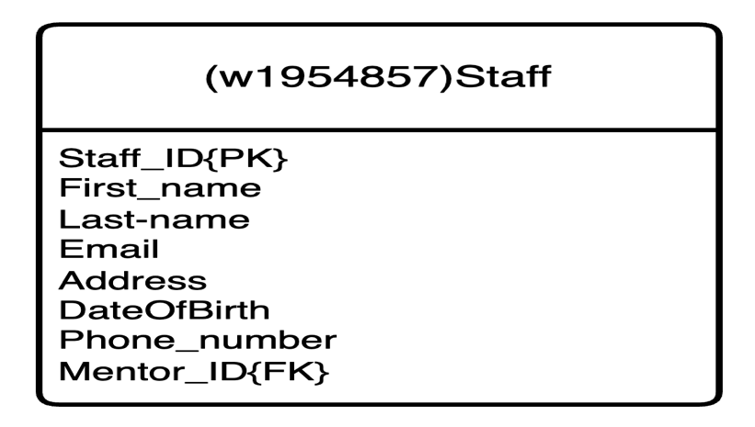

* **Staff manages Course:**

1. This is a one-to-one (1:1) relationship (optional on both sides).
2. Create two tables Two tables need to be created. That is, Staff and Course tables.
3. Staff table is made the Parent table since it is the stronger entity while the Course table is made the child table.
4. The foreign key of the Course table is the primary key of the Staff table.
5. Hence, the foreign key is Staff_ID.

**Logical ERD:**

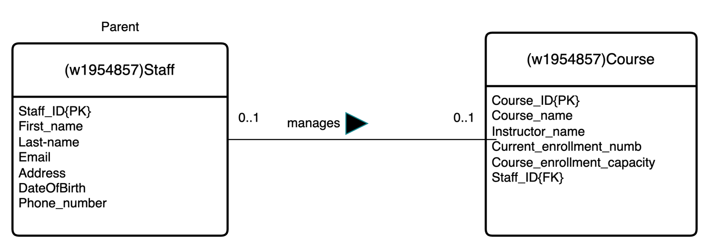

* **Staff leads Module:**

1. This is a one-to-many (1:M) relationship
2. Two tables are created namely the Staff entity and Module entity.
3. Parent entity is the entity that has a cardinality of “one”, that is Staff table and the Child entity is the entity that has a cardinality of “many”, that is Module table.
4. The foreign key is created on the Module table and it is the primary key of the staff entity.
5. Hence, the foreign key is Staff_ID which references the primary key of the Staff table.

**Logical ERD:**

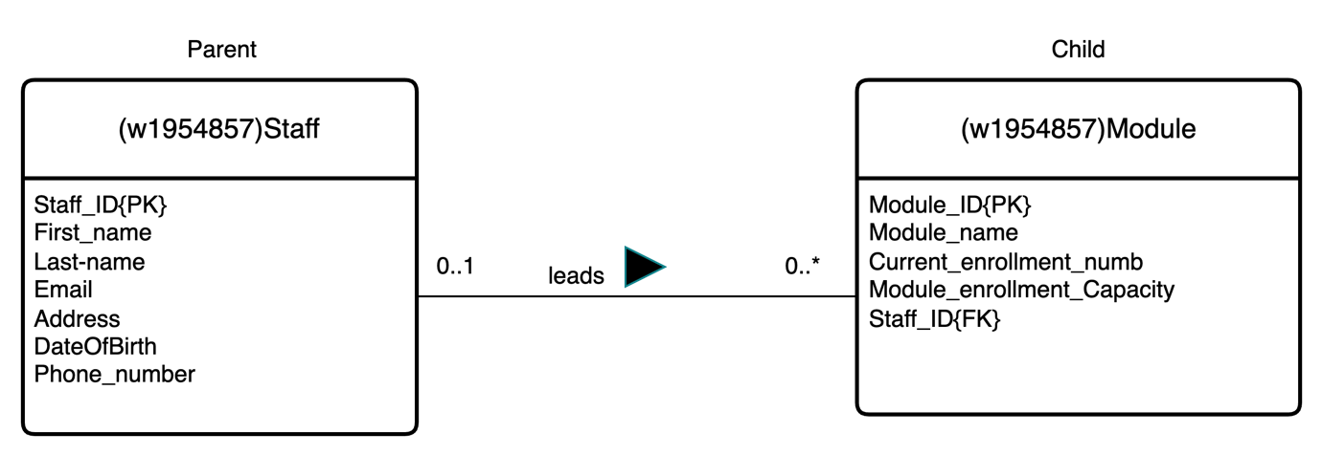

* **Staff delivers Module:**

1. This is a many-to-many (M:M) relationship.
2. Three tables are created, that is two Parent Tables and a link table as the Child table which is associated with the parent tables.
3. The two original parent tables are made of Staff and Module entities.
4. The link table is Child and is called the Staff_Module table.
5. Foreign keys of the Staff_Module table are the primary keys of both parent tables
6. Hence, the foreign keys are Staff_ID and Module_ID.
7. The primary key of the Staff_Module table is the combination of the two primary keys of Staff and Module entities.
8. Hence, the primary key of the link table is Staff_ID{FK}, Module{FK} making them a compound primary key as well.

**Logical ERD:**

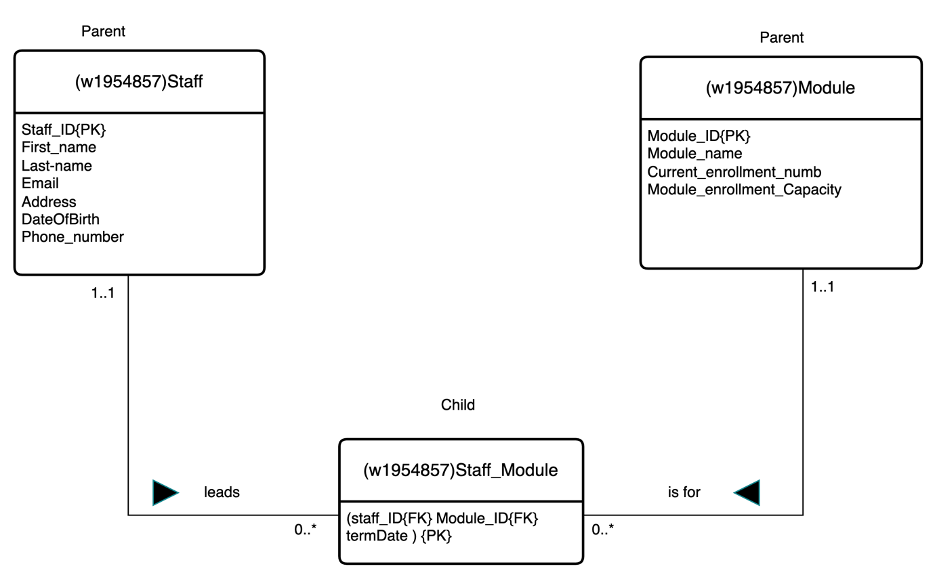

* **Course consists of Module:**

1. This is a one-to-many (1:M) relationship
2. Two tables are created namely the Course entity and Module entity.
3. Parent entity is the entity that has a cardinality of “one”, that is Course table and the Child entity is the entity that has a cardinality of “many”, that is Module table.
4. The foreign key is created on the Module table and it is the primary key of the Course entity.
5. Hence, the foreign key is Course_ID which references the primary key of the Course table.

**Logical ERD:**

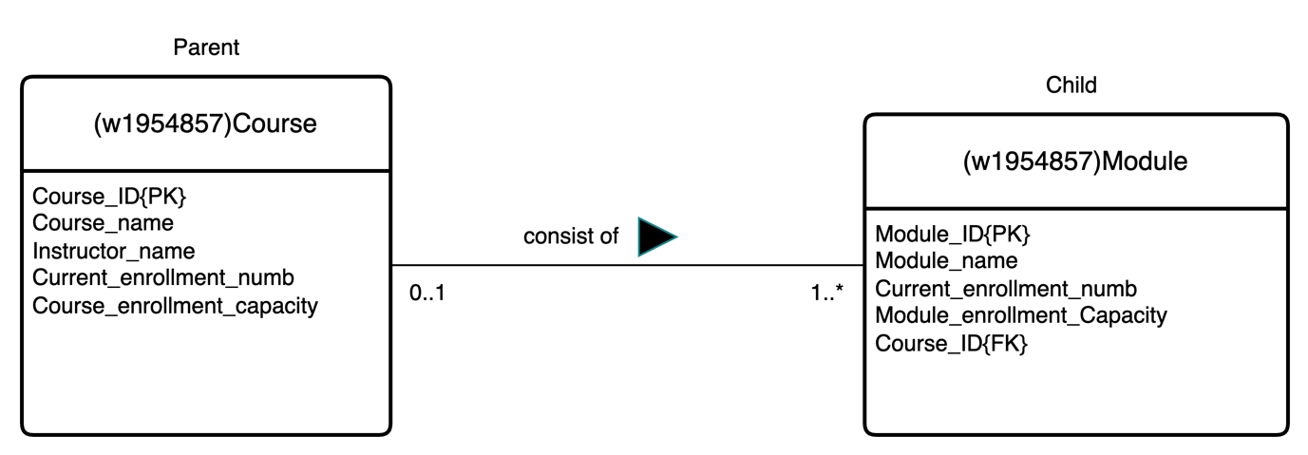

* **Student is registered on Course**

1. This is a one-to-many (1:M) relationship
2. Two tables are created namely the Course entity and Student entity.
3. Parent entity is the entity that has a cardinality of “one”, that is Course table and the Child entity is the entity that has a cardinality of “many”, that is Student table.
4. The foreign key is created on the Student table and it is the primary key of the Course entity.
5. Hence, the foreign key is Course_ID which references the primary key of the Course table.

**Logical ERD:**

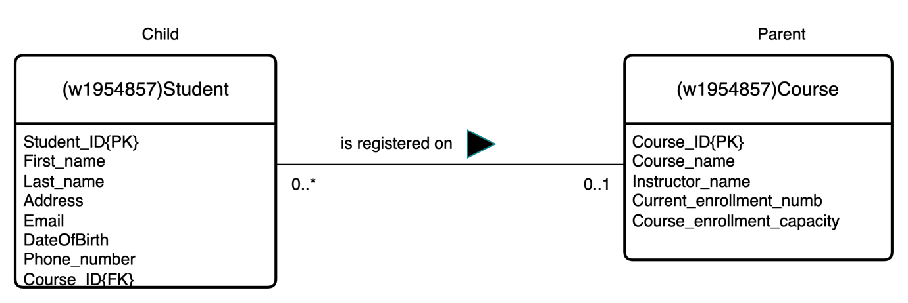

* **Student takes Module**

1. This is a many-to-many (M:M) relationship.
2. Three tables are created, that is two Parent Tables and a link table as the Child table which is associated with the parent tables.
3. The two original parent tables are made of Student and Module entities.
4. The link table is Child and is called the Student_Module table.
5. Foreign keys of the Student_Module table are the primary keys of both parent tables
6. Hence, the foreign keys are Staff_ID and Module_ID.
7. The primary key of the Student_Module table is the combination of the two primary keys of Staff and Module entities as well as an additional date since the combination of two primary keys can be repeated.
8. Hence, the primary key of the link table is Student_ID{FK}, Module{FK} and additional date which is “Taken_date” making it a composite primary key.

**Logical ERD:**

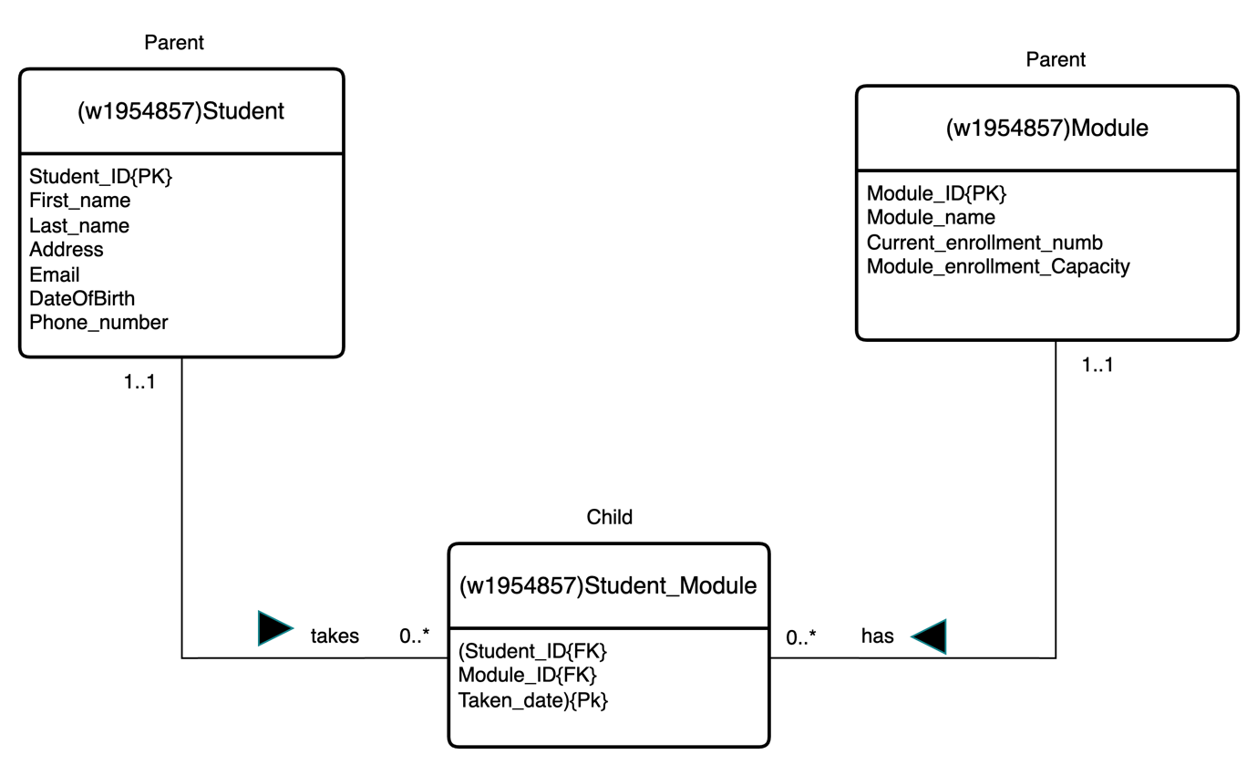

* **Lecturer(Staff) recommends a Textbook for each Module:**

1. This is a complex relationship(ternary).
2. Four tables are created, that is three Parent Tables and a link table as the Child table which is associated with the parent tables.
3. The three original parent tables are made of Staff, Module and Textbook entities.
4. The link table is Child and called the recommendation table.
5. The foreign keys of the Recommendation table are the primary keys of the parent tables
6. Hence, the foreign keys are Staff_ID, Module_ID and ISBN.
7. The primary key of the Recommendation table is the combination of the three primary keys of Staff, Module and Textbook entities as well as an additional date since the combination of three primary keys can be repeated.
8. Hence, the primary key of the link table is Staff_ID{FK}, Module{FK}, and the additional date is “Recommended_date” making it a composite primary key.

**Logical ERD:**

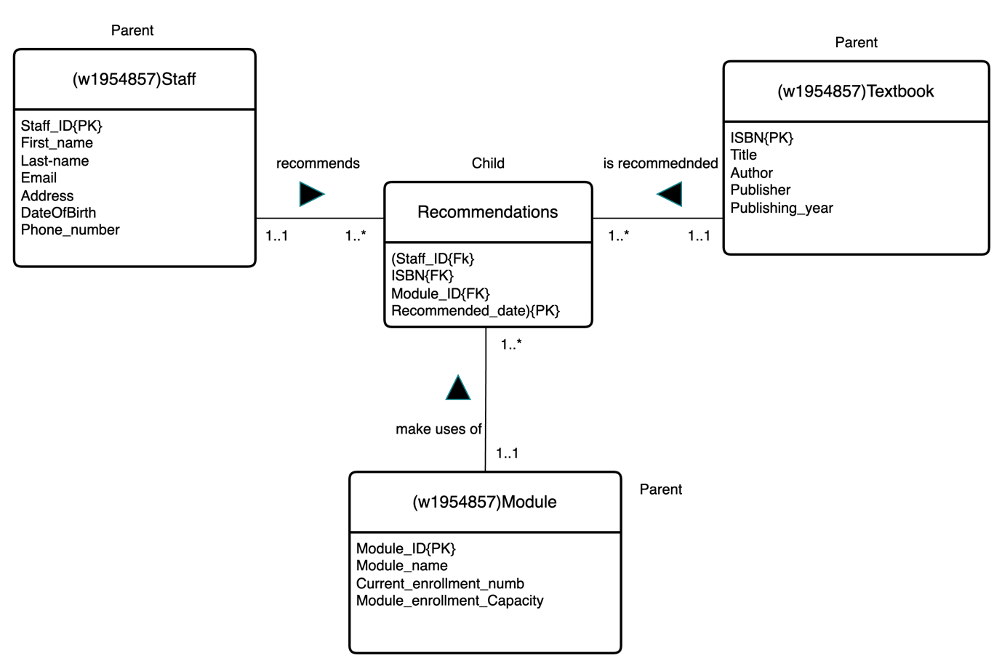

**EXCEL University logical ERD:**

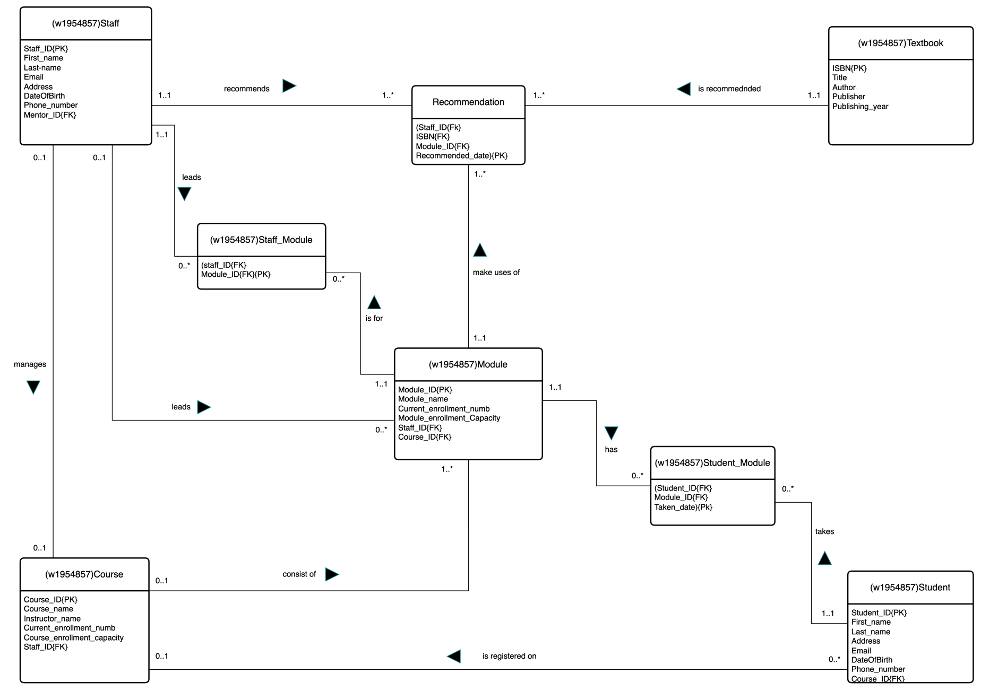

**PART A**

**THE MAIN ENTITIES OF THE DRIVING SCHOOL DATABASE:**

1. Office
2. Staff
3. Instructor
4. Client
5. Vehicle
6. Lesson
7. Staff

**THE MAIN RELATIONSHIPS BETWEEN THE ENTITIES(BINARY RELATIONSHIPS):**

1. Office has Staff.
2. Instructor is a staff.
3. Client registers at office.
4. Instructor interview client.
5. Client book Lesson.
6. Instructor is allocated a vehicle.
7. Client takes Test.

**QUATERNARY RELATIONSHIP:**

1. Client attends a lesson with a particular instructor in a particular vehicle at a given time.

**ATTRIBUTES AND MULTIPLICITIES FOR EACH RELATIONSHIP.**

1. Office has Staff.

* One office has a minimum of one staff.
* One office has a maximum of many staff.
* One staff belongs to a minimum of one office.
* One staff belongs to a maximum of one office.

1. Instructor is a staff.

* One instructor can be a minimum of one staff.
* One instructor can be a maximum of one staff.
* One staff is a minimum of zero instructors.
* One staff member is a maximum of one instructor.

1. Client registers at office.

* One Office registers a minimum of zero client
* One office registers a maximum of many clients
* One client registers at a minimum of one office
* One client registers at a maximum of one office

1. Instructor interview client.

* One instructor interviews a minimum of zero clients.
* One instructor interviews a maximum of many clients.
* One client is interviewed by a minimum of one instructor.
* One client is interviewed by a maximum of one instructor.

1. Client book Lesson.

* One client books a minimum of one lesson.
* One client books a maximum of many lessons.
* One lesson is booked by a minimum of one client.
* One lesson is booked by a maximum of one client.

1. Instructor is allocated a vehicle.

* One instructor is allocated a minimum of one vehicle.
* One instructor is allocated a maximum of one vehicle.
* One vehicle is allocated to a minimum of zero instructors.
* One vehicle is allocated to a maximum of one instructor.

1. Client takes Test.

* One client takes a minimum of one test.
* One client takes a maximum of many tests.
* One test is taken by a minimum of one client.
* One test is taken by a maximum of one client.

1. Client attends a lesson with a particular instructor in a particular vehicle at a given time.

* Client attends a minimum of one lesson with a particular instructor in a particular vehicle.
* Client attends a maximum of one lesson with a particular instructor in a particular vehicle.
* Client attends a lesson with a minimum of one instructor in a particular vehicle.
* Client attends a lesson with a maximum of one instructor in a particular vehicle.
* Client attends a lesson with a particular instructor in a minimum of one vehicle.
* Client attends a lesson with a particular instructor in a maximum of one vehicle.
* A minimum of one client attends a lesson with a particular instructor in a particular vehicle.
* A minimum of one client attends a lesson with a particular instructor in a particular vehicle.

**ERD representation of Driving School Database:**

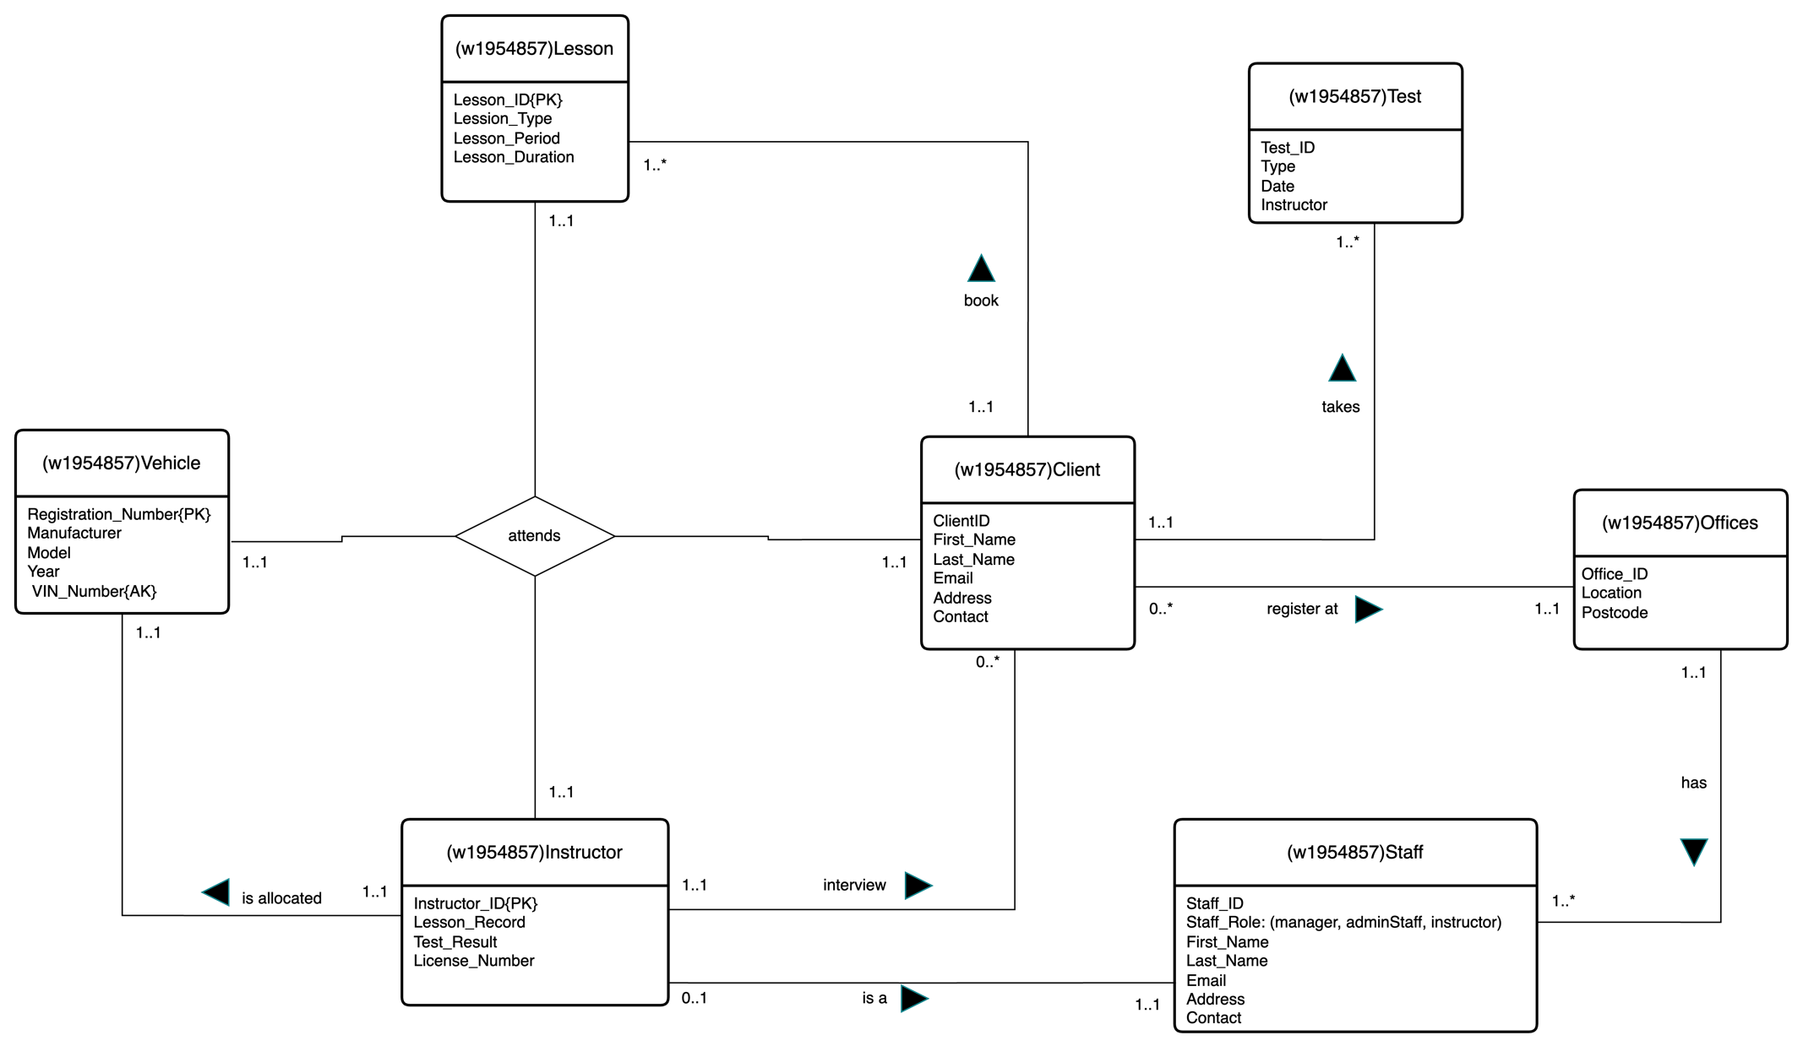

**PART C**

**3.1 Modification to the ERD.**

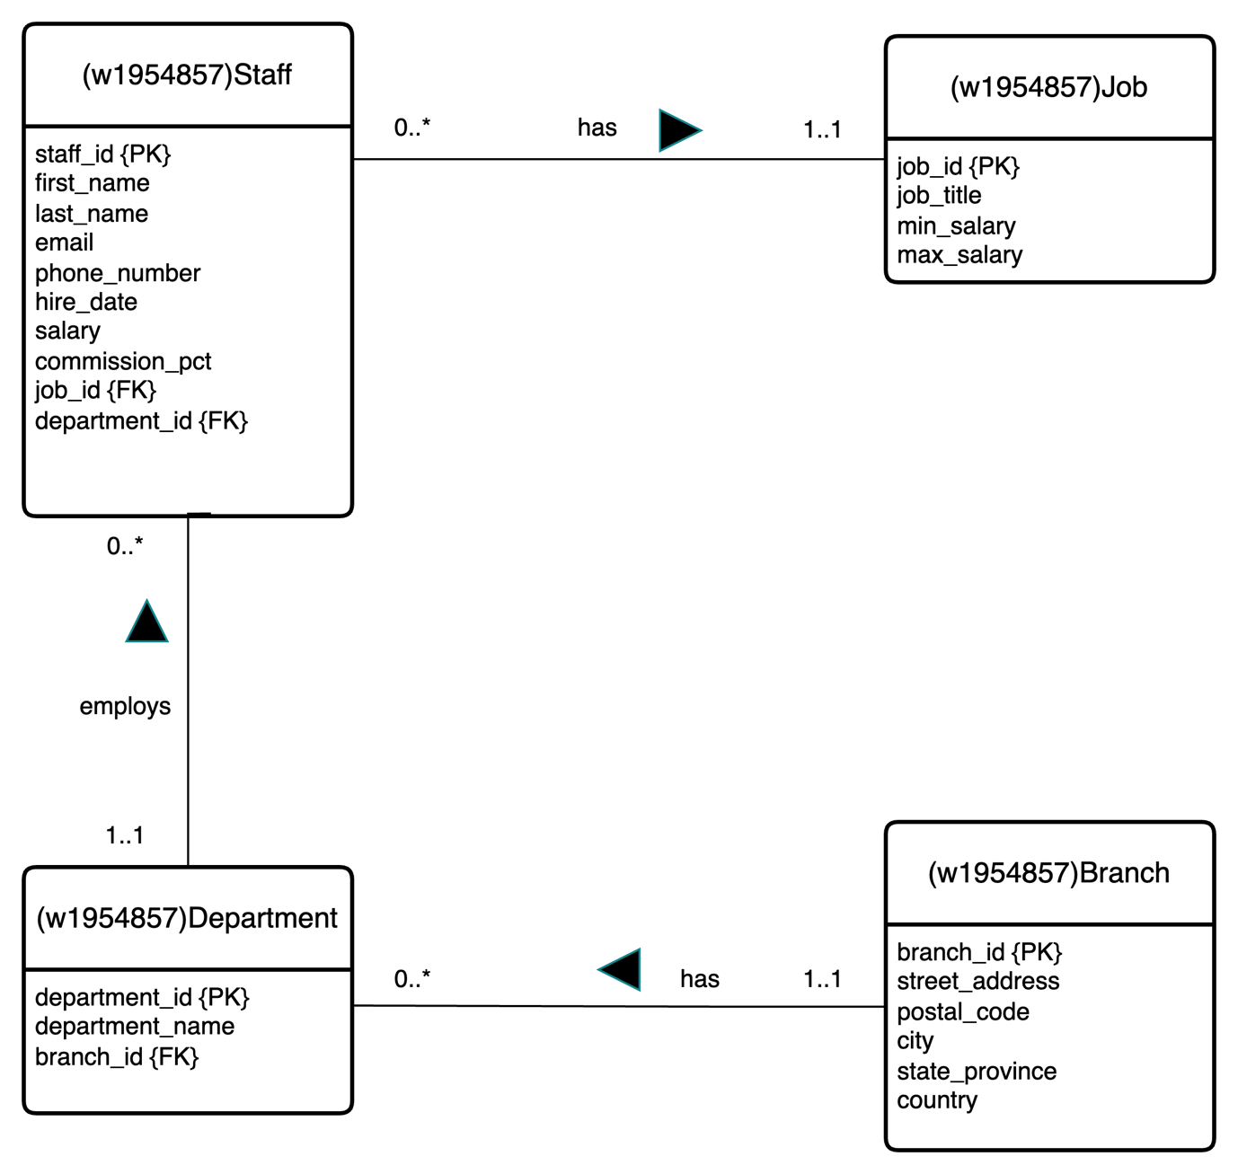

**3.2.** To create a department table, the branch table must be created first.

-- Creating branch table

CREATE TABLE w1954857_branch (

branch_id VARCHAR(4) ,

street_address VARCHAR(250) NOT NULL,

postal_code VARCHAR(20) NOT NULL,

city VARCHAR(100) NOT NULL,

state_province VARCHAR(100) NOT NULL,

country VARCHAR(100) NOT NULL,

CONSTRAINT b_bid_pk PRIMARY KEY (branch_id)

);

The department table is created by referencing the branch table.

-- Creating the department table

CREATE TABLE w1954857_department (

department_id VARCHAR(3),

department_name VARCHAR(250) NOT NULL,

branch_id VARCHAR(4),

CONSTRAINT d_did_pk PRIMARY KEY (department_ID),

CONSTRAINT d_bid_fk FOREIGN KEY (branch_id) REFERENCES w1954857_branch(branch_id)

);

SCREENSHOT:

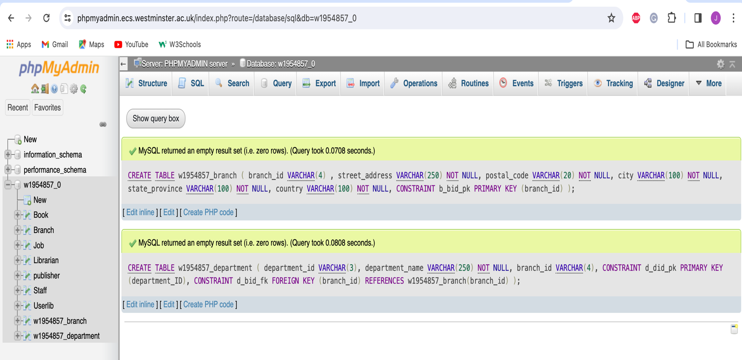

**3.3. Inserting content into the department table just created**

* Inserting branches_id:

SQL CODE:

-- Inserting Branches in Various UK Cities

INSERT INTO w2025844_branch (branch_id, street_address, postal_code, city, state_province, country)

VALUES

('B100', '101 Abbeywood Street', 'MA8 4AB', 'Manchester', 'Greater Manchester', 'United Kingdom'),

('B200', '202 Loampit Road', 'DA8 1FH', 'London', 'Greater London', 'United Kingdom'),

('B300', '303 Ilford Avenue', 'BC2 9EY', 'Birmingham', 'West Midlands', 'United Kingdom'),

('B400', '404 Dartford Street', 'EF9 6XG', 'Edinburgh', 'Scotland', 'United Kingdom');

* SCREENSHOT OF STRUCTURE OF THE BRANCH TABLE**:**

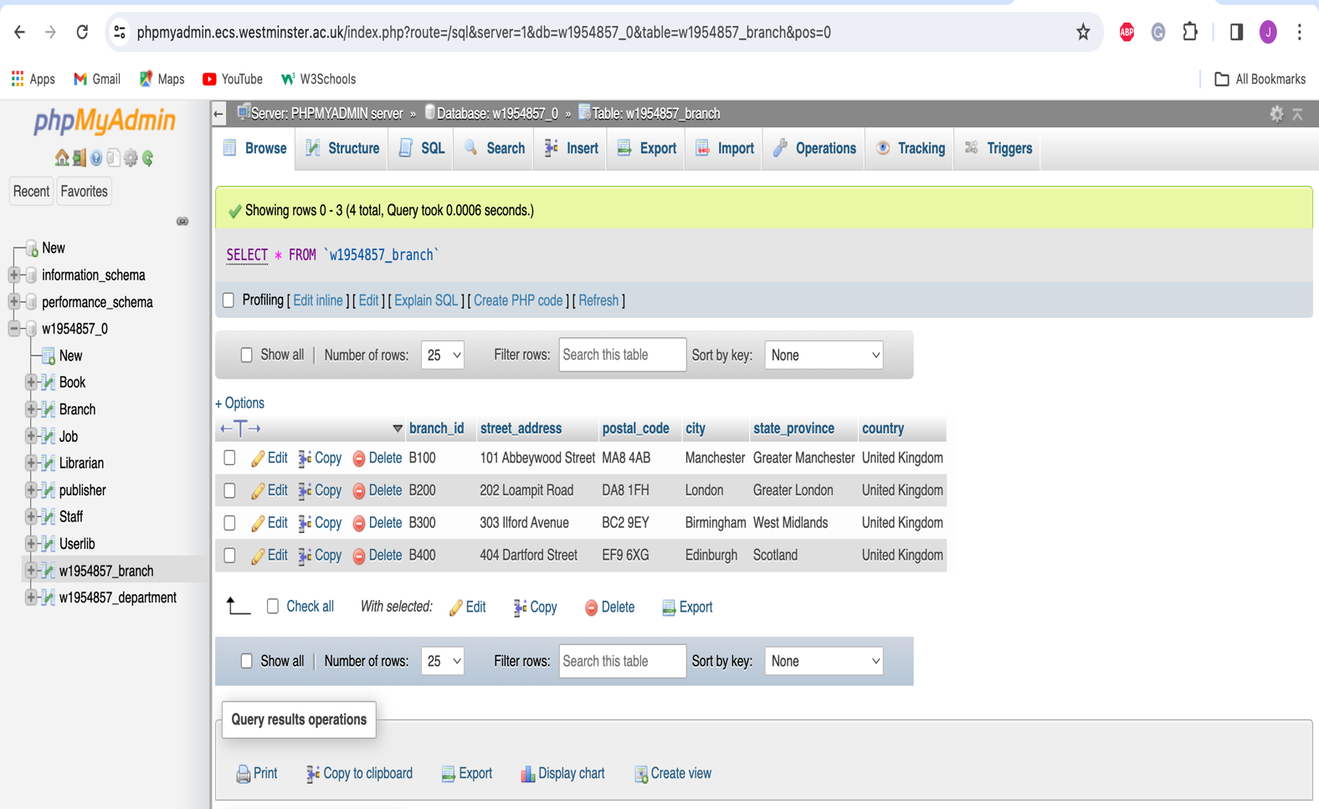

* Inserting departments:

SQL CODE:

-- Inserting Departments

INSERT INTO w2025844_department (department_ID, department_name, branch_id)

VALUES

('D10', 'IT', 'B100'),

('D20', 'Admin', 'B200'),

('D30', 'Sales', 'B300'),

('D40', 'Marketing', 'B400'),

('D50', 'Customer Care', 'B300');

* SCREENSHOT OF THE STRUCTURE OF DEPARTMENT TABLE**:**

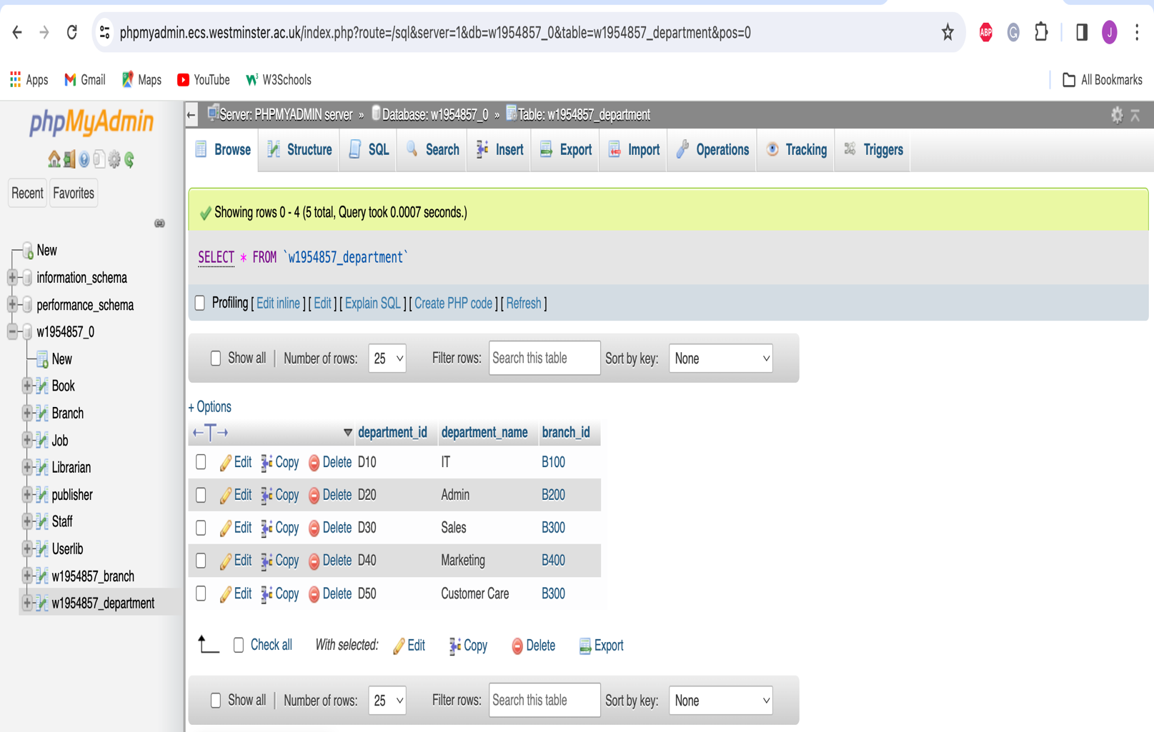

**3.4. To create a query to display/list,**

1. The job and staff table must be created.

SQL CODE:

-- Creating the Job table

CREATE TABLE w1954857_job (

job_id VARCHAR(3),

job_title VARCHAR(50) NOT NULL,

min_salary DECIMAL(10, 2) NOT NULL,

max_salary DECIMAL(10, 2) NOT NULL,

CONSTRAINT j_jid_pk PRIMARY KEY (job_id)

);

-- Creating the staff table

CREATE TABLE w1954857_staff (

staff_id VARCHAR(4),

first_name VARCHAR(50) NOT NULL,

last_name VARCHAR(50) NOT NULL,

email VARCHAR(100) NOT NULL UNIQUE,

phone_number VARCHAR(15) NOT NULL UNIQUE,

hire_date DATE NOT NULL,

salary DECIMAL(10, 2) NOT NULL,

commission_pct DECIMAL(4, 2),

department_ID VARCHAR(3) NOT NULL,

job_id VARCHAR(3) NOT NULL,

CONSTRAINT s_sid_pk PRIMARY KEY (staff_id),

CONSTRAINT s_jobid_fk FOREIGN KEY (job_id) REFERENCES w1954857_job(job_id),

CONSTRAINT s_did_fk FOREIGN KEY (department_ID) REFERENCES w1954857_department(department_ID)

);

Screenshot**:**

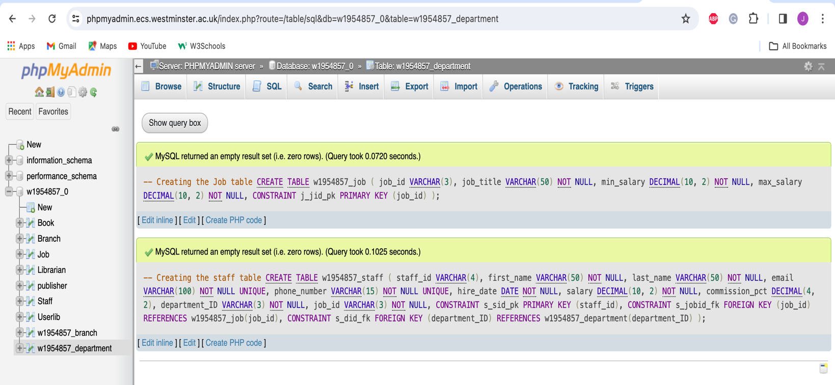

1. Inserting data into the job table.

SQL CODE:

-- Inserting data into job table

INSERT INTO w1954857_job (job_id, job_title, min_salary, max_salary)

VALUES

('901', 'Managing Director', 75000, 125000),

('902', 'Clerical Administrator', 28000, 41000),

('903', 'System Analyst', 45000, 95000),

('904', 'Security Officer', 30000, 55000),

('905', 'Network Operator', 37000, 68000),

('906', 'Data Entry Operator', 24000, 50000),

('907', 'Insurance Rep', 30000, 60000);

* SCREENSHOT OF STRUCTURE OF THE JOB TABLE:

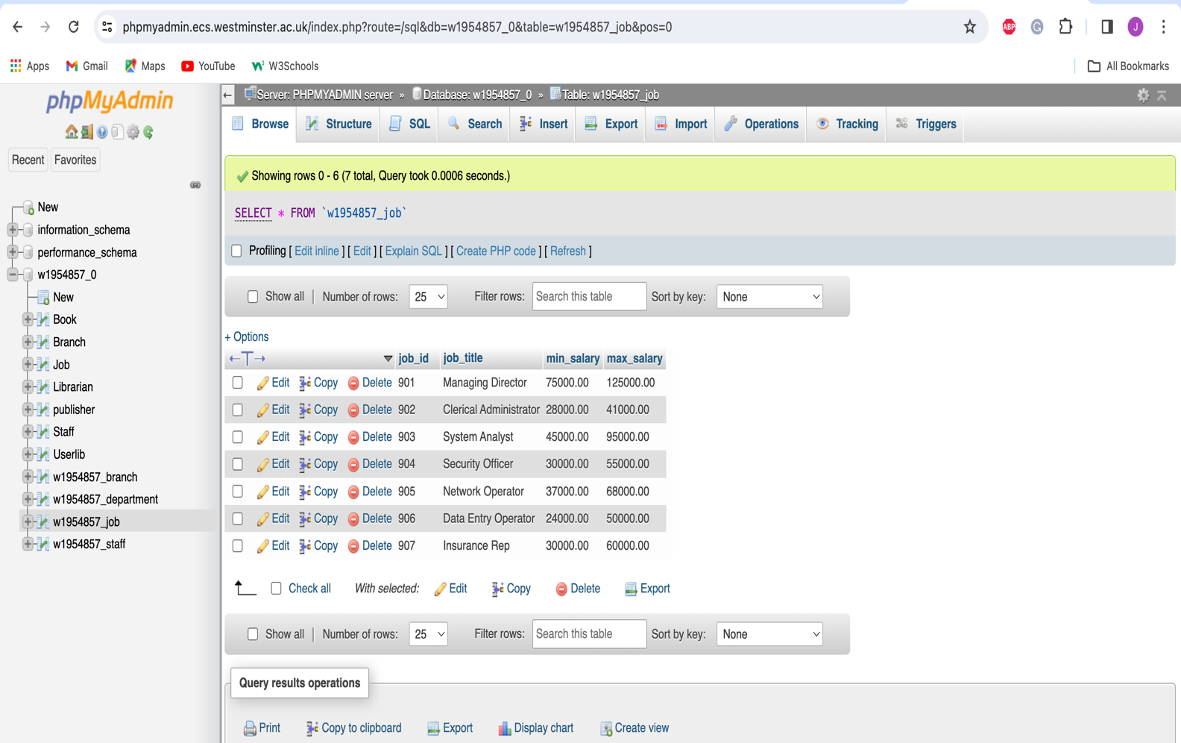

1. Inserting into staff table:

SQL CODE:

-- Inserting data into the staff table

INSERT INTO w1954857_staff (staff_id, first_name, last_name, email, phone_number, hire_date, salary, commission_pct, job_id, department_ID)

VALUES

(1001, 'Jim', 'King', 'jk@firm.com', '02079111001', '2011-01-21', 98000, NULL, 901, 'D10'),

(1002, 'Jane', 'Queen', 'jq@firm.com', '02079111002', '2012-02-05', 99000, NULL, 901, 'D20'),

(1003, 'Jen', 'Probert', 'jp@firm.com', '02079111003', '2014-11-23', 79000, NULL, 903, 'D10'),

(1004, 'Mike', 'Brent', 'mb@firm.com', '02079111004', '2013-10-06', 51000, NULL, 904, 'D20'),

(1005, 'Nadia', 'Tamsa', 'nt@firm.com', '02079111005', '2013-10-08', 62000, NULL, 905, 'D30'),

(1006, 'Mo', 'Ali', 'ma@firm.com', '02079111006', '2015-11-24', 41000, 0.15, 907, 'D40'),

(1007, 'Dannie', 'Kolova', 'dk@firm.com', '02079111007', '2016-05-15', 38000, 0.25, 907, 'D10'),

(1008, 'Manu', 'Ogoda', 'mo@firm.com', '02079111008', '2017-08-12', 33000, 0.35, 907, 'D20'),

(1009, 'Marc', 'Daniel', 'md@firm.com', '02079111009', '2014-01-02', 35000, 0.35, 907, 'D30'),

(1010, 'Louise', 'Matos', 'lm@firm.com', '02079111010', '2017-11-05', 53000, NULL, 905, 'D20'),

(1011, 'Ram', 'Binghi', 'rb@firm.com', '02079111011', '2012-03-30', 35000, NULL, 906, 'D10'),

(1012, 'Tim', 'Norm', 'tn@firm.com', '02079111012', '2018-03-31', 48000, NULL, 906, 'D30'),

(1013, 'Alex', 'Smart', 'as@firm.com', '02079111013', '2012-03-30', 39000, NULL, 905, 'D10'),

(1014, 'Bruno', 'Silba', 'bs@firm.com', '02079111014', '2014-05-08', 37000, NULL, 905, 'D40'),

(1015, 'Laurie', 'Kaldav', 'lk@firm.com', '02079111015', '2017-08-11', 34000, NULL, 902, 'D10'),

(1016, 'Sophie', 'Lanou', 'sl@firm.com', '02079111016', '2017-08-19', 34000, NULL, 902, 'D20'),

(1017, 'Yann', 'Taylor', 'yt@firm.com', '02079111017', '2018-09-03', 44000, NULL, 904, 'D30'),

(1018, 'Sam', 'Tring', 'st@firm.com', '02079111018', '2018-09-05', 47000, NULL, 903, 'D20'),

(1019, 'Don', 'Matos', 'dt@firm.com', '02079111019', '2017-10-04', 49000, NULL, 903, 'D30'),

(1020, 'Dan', 'Mitch', 'dm@firm.com', '02079111020', '2019-01-14', 35000, NULL, 902, 'D30'),

(1021, 'Jean', 'Novski', 'jn@firm.com', '02079111021', '2019-02-13', 38000, NULL, 906, 'D20'),

(1022, 'Malia', 'Mundi', 'mm@firm.com', '02079111022', '2019-07-15', 43000, NULL, 906, 'D30'),

(1023, 'Kurt', 'Thorpe', 'kt@firm.com', '02079111023', '2019-07-15', 44000, NULL, 906, 'D40');

SCREENSHOT OF STRUCTURE OF THE STAFF TABLE :

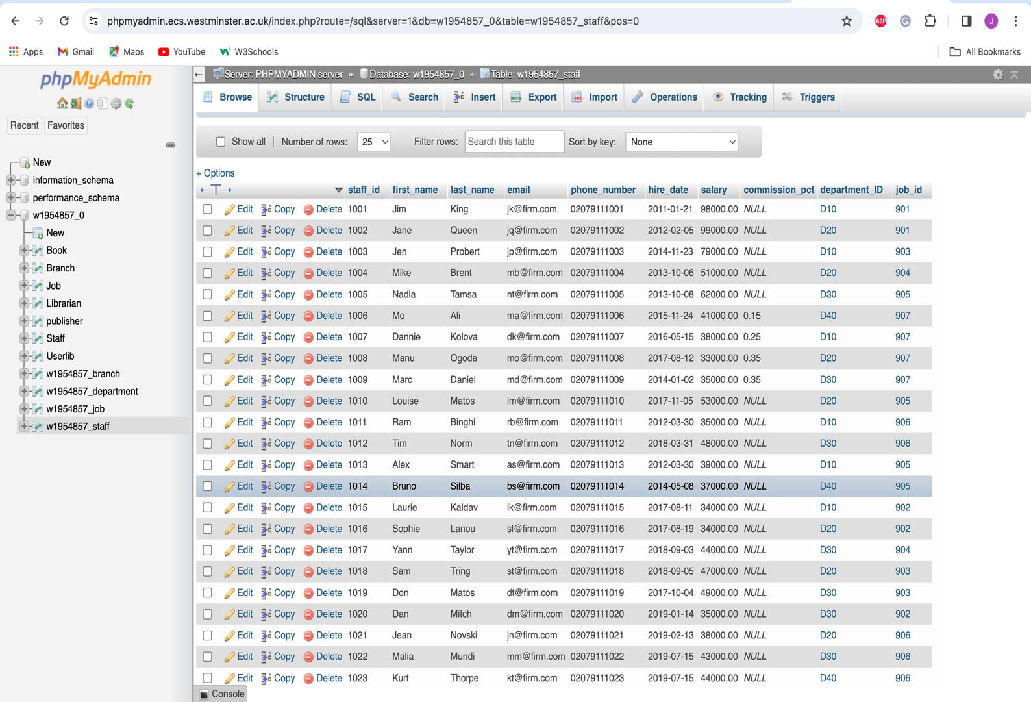

1. An SQL query to display the branch id, street address and postal code for all the branches situated under the postcode starting from “B”. Ordered in ascending order by branch id.

SQL CODE:

SELECT branch_id,street_address,postal_code

FROM w1954857_branch

WHERE postal_code LIKE 'B%'

ORDER BY branch_id ASC;

Screenshot of query:

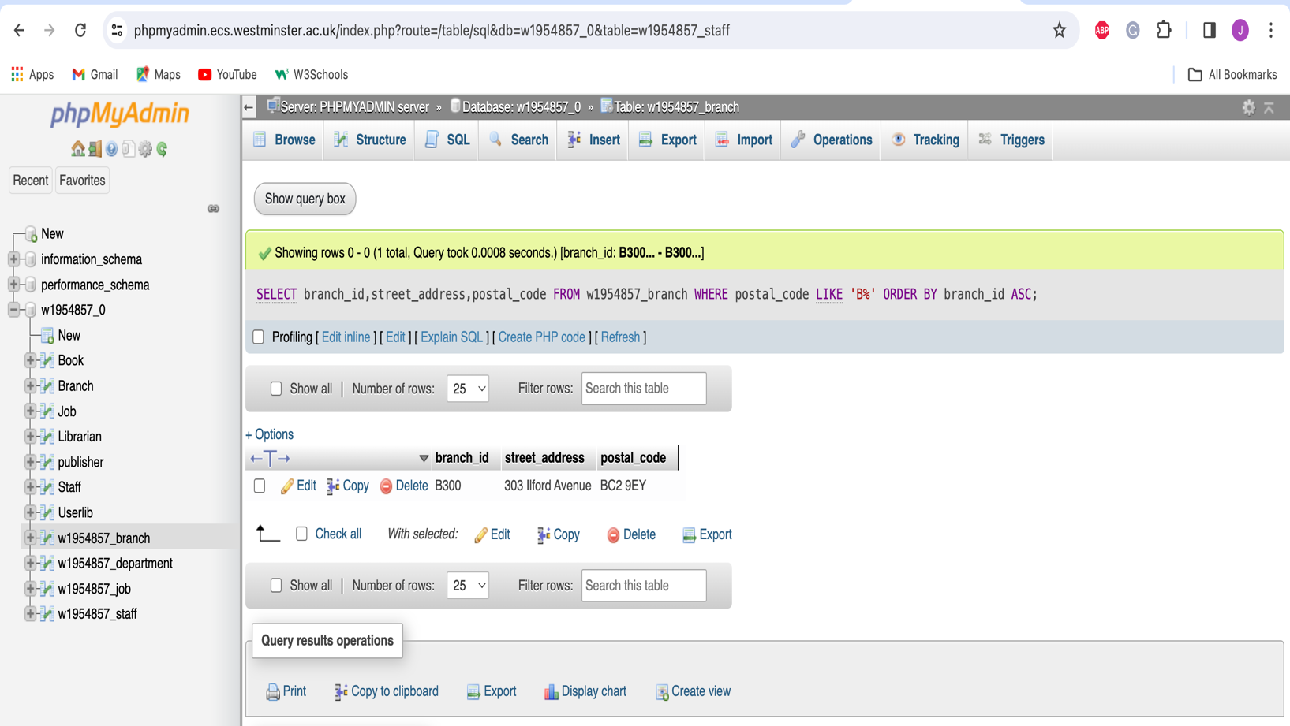

1. The job id, job title and maximum salary of employees who might earn a maximum salary of 50000 and above and is working as an operator.

SQL CODE:

SELECT Job_id,job_title,max_salary

FROM w1954857_job

WHERE (max_salary >= 50000) AND (job_title LIKE '%Operator%');

Screenshot of query:

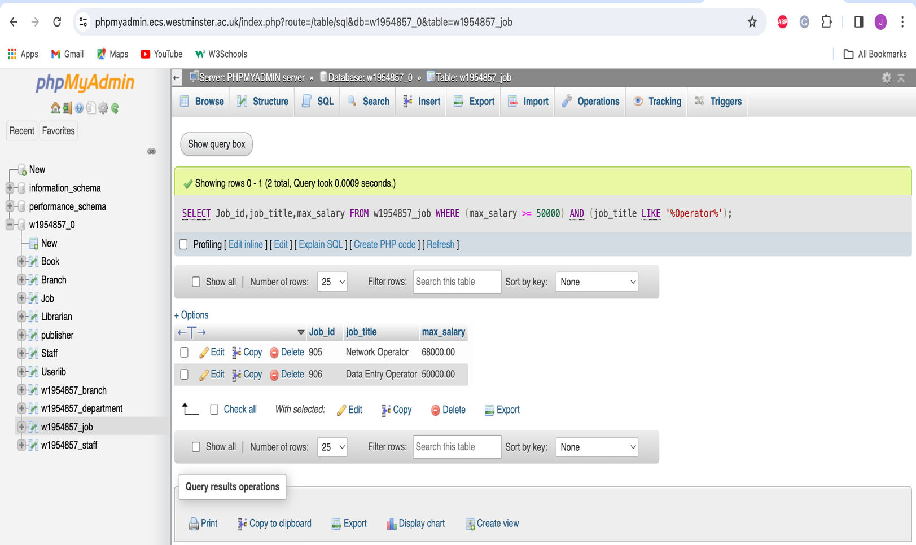

c) The last name, job id, hire date and salary of employees who work in branch B200 and

who earns less than 50000 and greater than 60000, as well as those who work in the same

branch and were hired before the 15th August 2017.

SQL CODE:

SELECT s.last_name, s.job_id, s.hire_date, s.salary

FROM w1954857_staff s

JOIN w1954857_department d ON s.department_ID = d.department_ID

WHERE (d.branch_id = 'B200' AND (s.salary < 50000 OR s.salary > 60000))

OR (d.branch_id = 'B200' AND s.hire_date < '2017-08-15');

Screenshot of query:

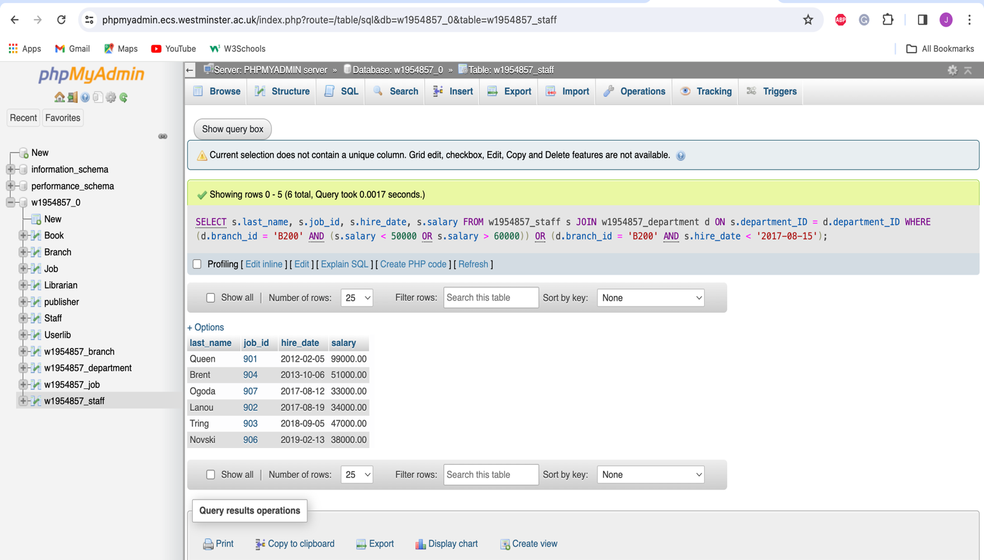

1. The last name, job, and salary for all employees whose job id is 907 and whose salary is not equal to £33,000 or £53,000.

SQL CODE:

1. SELECT last_name, job_id, salary
2. FROM w1954857_staff
3. WHERE job_id = '907'
4. AND salary NOT IN (33000, 53000);

Screenshot:

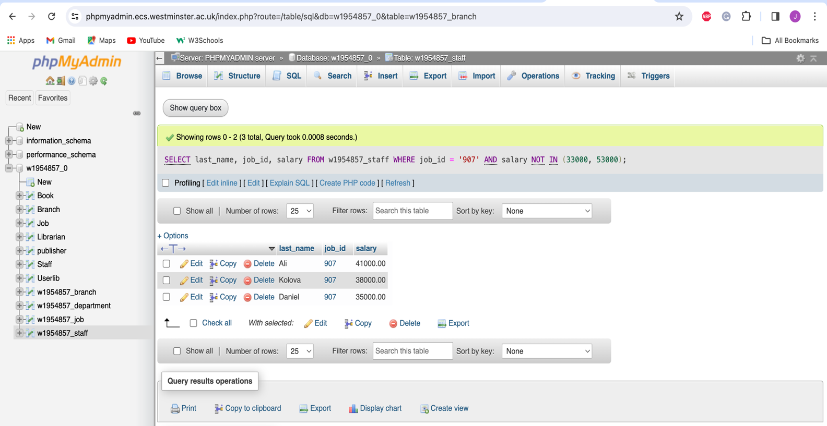

e) The minimum and maximum salary of Managing Director. Label the columns as Salary

Range MIN and Salary Range MAX.

SELECT MIN(min_salary) AS "Salary Range Min", MAX(max_salary) AS "Salary Range Max"

FROM w1954857_job

WHERE job_title = 'Managing Director';

